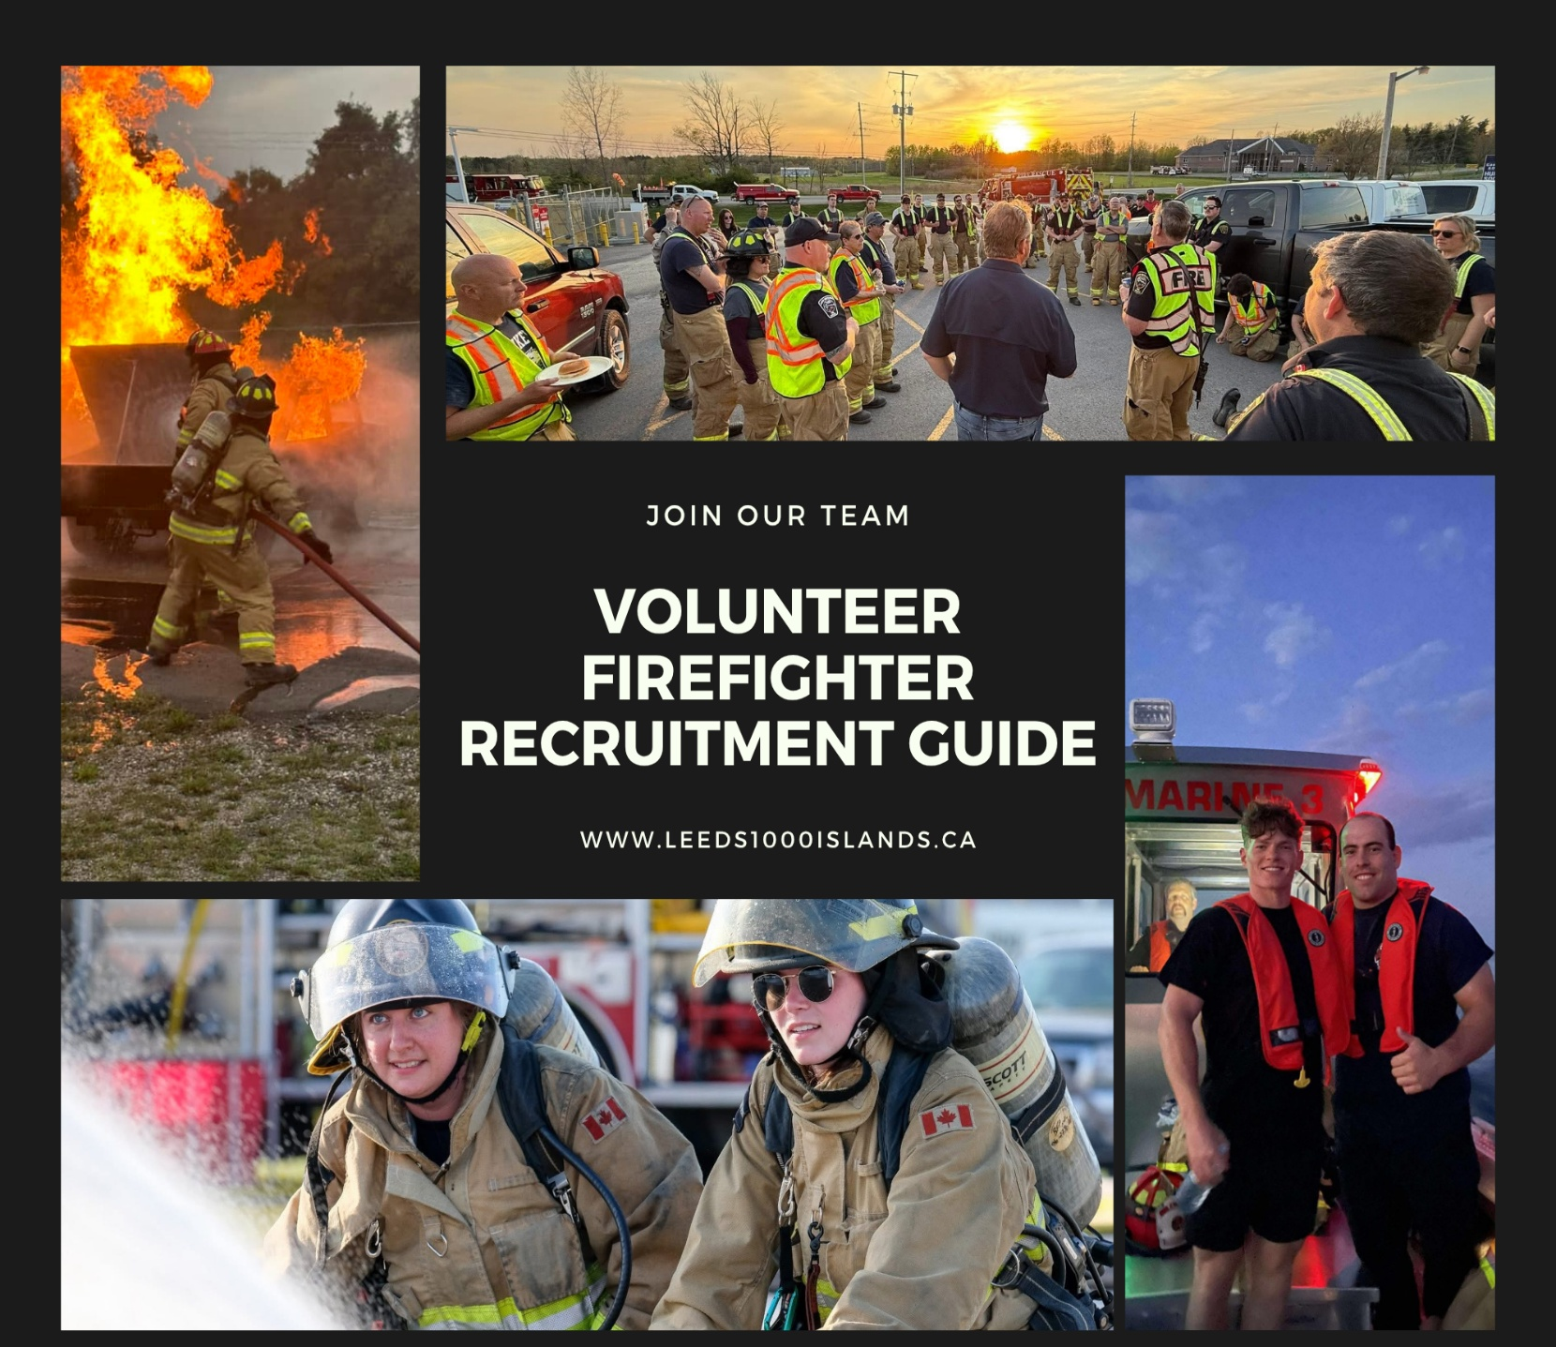

Table of Contents

Purpose 3
Preamble 3
Fire Protection Services in Ontario 3
Leeds 1000 Islands Fire Service 3
Eligibility 4
Administration 4
Job Description 4
Remuneration 5
Recruitment 5
Probation 6
Onboarding and Training 6
Volunteer Firefighter Application 6
Volunteer Firefighter Job Description 8
Volunteer Firefighter Medical Certificate 10

Purpose
The purpose of this Volunteer Firefighter Orientation and Recruitment Guide is to provide potential applicants with details of the recruitment of volunteer firefighters for the Leeds 1000 Islands Fire Service.

Preamble
Thank you for your interest in the Leeds 1000 Islands Fire Service. Serving the community as a volunteer firefighter can be a rewarding experience. This guide has been developed as a resource to better inform individuals about the commitment of serving as an active member of the Leeds 1000 Islands Fire Service. We trust the detail within the guide will supply information that will assist those who consider their aspiration to serve as a volunteer firefighter in their community. To serve as a volunteer firefighter safely and effectively, it requires serious personal commitment. Your decision to join should not be made quickly.
The guide contains information about the Township of Leeds and the Thousand Islands and the Leeds 1000 Islands Fire Service. We recognize this guide may not answer all possible questions about becoming a Leeds 1000 Islands Fire Service volunteer firefighter.
Whether you have previous experience with another fire department, or no experience at all, please take the time to review all areas of this guide and familiarize yourself with the Leeds 1000 Islands Fire Service and the fire protection services provided in the Township of Leeds and the Thousand Islands.

Once you are better informed about becoming a volunteer firefighter with the Leeds 1000 Islands Fire Service, and if it is your aspiration to start an official application, we hope you will be able to fulfill the commitment that the community requires. The service supplied by volunteer firefighters is truly respected by the citizens living, working, and visiting our community, they look up to you!

Fire Protection Services in Ontario
In Ontario, provincial regulations place responsibility for Fire Protection Services with the municipality. The service levels provided vary from municipality to municipality and are based on the needs and circumstances of each municipality. Council, under the guidance of the Fire Chief, approves service levels and the necessary resources through corporate operating and capital budgets.

Leeds 1000 Islands Fire Service
The Township is served by a volunteer municipal fire service comprising of four (4) stations – Lansdowne, Seeley’s Bay, Lyndhurst and outside of Gananoque within the Township border. The service adheres to the Establishing and Regulating By-law (E&R By-law) which provides direction on how the municipality intends the fire protection services to operate. The team also includes a full-time Fire Chief, Fire Prevention Officer and Fire Administrative Coordinator.

Eligibility
The Leeds 1000 Islands Fire Service has established their requirements for a volunteer firefighter employment position, based on the needs of the municipality.

An individual considering applying for the position of volunteer firefighter with the Leeds 1000 Islands Fire Service

- Possesses an Ontario High School Graduation Diploma or equivalent;
- Upon joining the Fire Service, Probationary Firefighters must enroll in the next NFPA 1001 offered to new Firefighters by the Township, unless granted a deferral by the Fire Chief. Firefighters, including Probationary Firefighters, must become a Certified Firefighter within thirty-six (36) months of joining the Fire Service;
- Maintain confidentiality;
- Attend at minimum sixty (60) percent of in-station training and twenty-five (25) percent of emergency calls in a calendar year;
- Possesses a valid and unrestricted Ontario Class “G” Driver’s License;
- Required to successfully attain an Ontario “D” driver’s licence with “Z” endorsement within one (1) year of employment;
- Possess superior interpersonal skills and the ability to work cooperatively as a member of an effective and professional team;
- Have a strong desire to serve the community, possess a strong work ethic, sense of loyalty and duty, coupled with the ability and willingness to follow instructions promptly and efficiently.
- Must be 18 years of age or older or at the discretion of the Fire Chief;
- Must provide a satisfactory Vulnerable Sector Check;
- Must provide a satisfactory driver’s abstract;
- Must complete the medical certificate indicating medically capable of completing the position;
- Must be legally entitled to work in Canada;
- Must live in proximity to one of the Township’s four (4) fire stations.

A job description for the position of volunteer firefighter has been provided at the end of this guide.
All firefighters are required to attend at minimum 60% of in-station training
and 25% of emergency calls in a calendar year.

Remuneration
Firefighters are referred to as “volunteer firefighters” in accordance with the Fire Protection and Prevention Act. Volunteer firefighters are compensated a minimum one (1) hour for emergency responses regardless of the time spent at an incident. All hours worked will be subject to all Provincial and Federal statutory deductions. Volunteer Firefighters who choose to participate in the OMERS pension plan will also be subject to deductions as required by OMERS.

A probationary recruit firefighter will be compensated in accordance with the classification and rate provided in Leeds 1000 Islands Fire Service remuneration policy, as adopted by the Council.

Recruitment
Step 1:
Each station has regularly scheduled monthly “walk-in” sessions where interested applicants can visit their local station to meet the Captain, senior officers and firefighters to observe training, take a tour of the station, discuss the opportunity of becoming a volunteer firefighter and ask questions.

Are you a qualified firefighter?
Interested applicants who have obtained the required qualifications can complete the Volunteer Firefighter Application including proof of current qualification(s), completed Volunteer Firefighter Medical Certificate, a copy of a Vulnerable Sector Check in good standing and a current Driver’s Abstract. Email application and supporting documentation to fireadmin@townshipleeds.on.ca

Are you a new applicant with no previous experience?
Interested applicants with no prior experience are strongly encouraged to attend a “walk-in” at their local station. Upon understanding the commitment of a Volunteer Firefighter, the applicant can complete the application including completed Volunteer Firefighter Medical Certificate, a completed Vulnerable Sector Check in good standing and a current Driver’s Abstract. Email application and supporting documentation to fireadmin@townshipleeds.on.ca

Step 2:
Upon receiving the Volunteer Firefighter Application and supporting documentation, the Fire Chief will review all required documentation to ensure they are complete and in good standing. Once this process has been completed, the Fire Administrative Coordinator will contact you to schedule an interview. Interviews will be conducted by the Fire Service.
Step 3:
Candidates who have submitted their application including the required supporting documentation in good standing and have successfully completed their interview will be provided with an offer of employment with the Leeds 1000 Islands Fire Service. Once the offer of employment has been signed, the Volunteer Firefighter cannot report to their station until all payroll documentation has been completed and verified by the Fire Administrative Coordinator.
Completion of all required documentation listed above will be at the candidate’s own expense.

Probation
A Volunteer Firefighter will be on probation for a period of twelve (12) months from the hire date. During the probationary period a firefighter will be evaluated and assessed on attendance, order, performance, skill, and other employment-related attributes.

Following the 12-month probationary period and a successful evaluation, the recruit is subject to moving to permanent volunteer firefighter status. Should further assessment time be deemed necessary, the probationary period may be extended for a period up to three (3) additional months.

Onboarding and Training
All new Volunteer Firefighters regardless of previous firefighter experience will be required to complete human resources onboarding and fire training as required based on current certification, if any.

Human resources onboarding must be completed within two (2) weeks of their start date and can be completed at their home. Information on the required training and reading will be provided once all required documentation has been provided.

Volunteer Firefighters will be required to arrange their schedules for 100% attendance to complete the required training mandated by provincial regulations. Considerable personal commitment is required to attend certification training at a regional training centre. This commitment may include a combination of self-directed learning and several weekends attending a regional training centre. If the Volunteer Firefighter has been previously certified to a fire department service level equal to (or exceeding) the Leeds Islands Fire Service level the individual will not be required to attend a scheduled Ontario Fire College course at a regional training centre. Proof of certification is required.

A portion of firefighter training requires self-directed learning involving extensive reading or pre-course assignments outside of normal training hours.

Volunteer Firefighter Application

Please complete the application in full. Ensure your application is legible and complete.

First and Last Name:
Address:
Phone Number:
Are you 18 years of age or older: ☐ No ☐ Yes Do you have access to a reliable vehicle: ☐ No ☐ Yes
Do you possess an Ontario high school diploma or equivalent: ☐ No ☐ Yes
Present Employer: Position Title:

Current Hours of Work: (days, nights, weekends, shift work)
What is your availability to attend emergency calls & training? (day/evening/night, weekdays, weekends, times)

Current First-aid/CPR certification: ☐No ☐Yes – level: Completion Date:
Previous firefighting experience: ☐No ☐ Yes (if yes, list with dates served. Include certifications below)

By signing this volunteer firefighter application and submitting it to the Leeds 1000 Islands Fire Service, you acknowledge that you meet all requirements as outlined in the volunteer firefighter orientation and recruitment guide for a volunteer firefighter employment position.
A completed application with attachments may be delivered in the following ways:
Email: fireadmin@townshipleeds.on.ca
In-Person: 1000 Islands Fire Service (Township of Leeds and Thousand Islands Administration Office) 1233 Prince St. Lansdowne
Mail: Leeds 1000 Islands Fire Service P.O. Box 280 Lansdowne, ON K0E 1L0

Signature of Applicant: _____________________________________ Date: ______________________

We will hold individual applications in strict confidence. Information provided in an application will be used for the purpose of employment assessment for a firefighter position with the Township of Leeds and the Thousand Islands. Personal information provided is in accordance with the Municipal Freedom of Information and Protection Privacy Act.

For Office Use Only: | Date Received:
Screener: |  | Status:

Volunteer Firefighter Job Description

POSITION TITLE: Volunteer Firefighter
REPORTS TO: Fire Chief
SUBORDINATE POSITIONS: N/A
DATE: June 20, 2025

POSITION SUMMARY:

Firefighters respond to emergency situations and protect people, the environment and property from all types of incidents and situations. The position is of a hazardous nature involving firefighting, rescue, and patient care performed under the direction and supervision of fire officers. Firefighters also work closely with the local community to increase fire safety awareness and to aid in the prevention of fires and incidents. Lectures, static displays at community events, practical drills, and core training are all integral and ongoing parts of a firefighter position.

RESPONSIBILITIES:

- Available to respond safely to emergency calls and calls for assistance 24 hours per day, 7 days per week in accordance with attendance guidelines. This position may involve working on weekends, holidays and in all types of weather conditions.
- Drives, operates and maintains emergency equipment, as well as personal vehicles, safely and in accordance with policies, guidelines and applicable legislation.
- Enters burning or contaminated structures, and other areas to perform rescues and/or fight fires while wearing appropriate personal protective equipment (PPE)
- Apply proper firefighting and/or rescue techniques needed to control and/or extinguish fires and extricate people.
- Minimizes distress and suffering, including the provision of first aid/CPR prior to EMS arrival; safeguarding their own and other people’s personal safety at all times.
- Wears, maintains and properly uses all appropriate PPE as supplied by the fire service.
- Communicates appropriately in accordance with established guidelines.
- Attend training sessions to maintain and upgrade firefighting skills in accordance with established policies and operational guidelines.
- Attend at minimum sixty (60) percent of in-station training and twenty-five (25) percent of emergency calls in a calendar year.
- Ability to deal with the public in a polite, sympathetic and efficient manner, regardless of how frustrating or unnerving the situation may be.
- Ability to cope with a high level of stress and perform all duties efficiently during an emergency situation.
- Ability to speak in a clear, articulate manner.
- There may be times when firefighters will be required to make decisions and work without supervision until an officer arrives on scene.
- Maintain links with local community and educate and inform the public to help promote fire safety, (i.e.) station tours, assisting in fire safety education programs, parades etc.
- Must maintain a high degree of confidentiality at all times.
- Refrains from disclosing information to the news media or other persons without authorization from the Fire Chief.
- Cooperates with OPP (police), EMS and others.
- Will respect and follow the chain of command, complying with orders from ranking department officers.
- Works in accordance with established policies, operational guidelines and the Occupational Health and Safety Act inclusive of any other relevant legislation or orders.
- Reports to duty fit for work and not impaired by prescribed medication(s), stress or by the use of substances such as drugs or alcohol.
- Maintains a level of physical fitness necessary to carry out all the duties of firefighter.
- All activities are expected to be performed in a safe manner, in accordance with the Occupational Health and Safety Act and its regulations, along with Township safety policies, procedures and programs. In addition, all necessary personal protective equipment must be used and maintained in good condition
QUALIFICATIONS:

- Possesses an Ontario High School Graduation Diploma or equivalent;
- Probationary Firefighters must enroll in the next NFPA 1001 offered to new Firefighters by the Township. Firefighters, including Probationary Firefighters, must become a Certified Firefighter within thirty-six (36) months of joining the Fire Service;
- Possesses a valid and unrestricted Ontario Class “G” Driver’s License;
- Required to successfully attain an Ontario “D” driver’s licence with “Z” endorsement within one (1) year of employment;
- Possess superior interpersonal skills and the ability to work cooperatively as a member of an effective and professional team;
- Have a strong desire to serve the community, possess a strong work ethic, sense of loyalty and duty, coupled with the ability and willingness to follow instructions promptly and efficiently.
- Must be 18 years of age or older;
- Must provide a satisfactory Vulnerable Sector Check;
- Must complete the medial certificate indicating medically capable of completing the essential duties of the position.
- Must be legally entitled to work in Canada;
- Must live in proximity to one of the Township’s four (4) fire station.

Volunteer Firefighter Medical Certificate
To be completed by a certified medical practitioner

Dear Medical Practitioner:
Your patient has conditionally been offered the position of Volunteer Firefighter with the Township of Leeds and the Thousand Islands Fire Service. As a condition of employment, your patient must obtain a medical certificate indicating if s/he is medically capable of completing the essential duties of the position.
The Volunteer Firefighters’ work environment often involves exposure to hazardous conditions and performing tasks at high levels of physical exertion at times in stressful conditions. Volunteer Firefighters are to be physically and mentally competent to perform all of the tasks and functions associated with being a Firefighter.

Tasks Include: Carrying, lifting, pulling, chopping, climbing stairs and ladders, wearing self-contained breathing apparatus (SCBA), entering and working in confined spaces and operating emergency vehicles, among others.
Environmental
Factors: Possible exposure to toxic gases and particles, chemicals, wet and damp conditions and extreme temperature variations.

Stress: Firefighting requires a Volunteer Firefighter to go from minimal physical activity to the peak of physical activity while responding to and performing firefighting or related tasks. As well as physical stress, a Volunteer Firefighter may be exposed to emotional stress while performing medical or rescue activities.

Medical Clearance
I have read the above information regarding the physical demands of a Volunteer Firefighter and based upon the information available during my examination of the individual in my professional opinion is:
☐ Able to perform the key essential duties of a Volunteer Firefighter
☐ Not be able to perform the key essential duties of a Volunteer Firefighter
Medical Practitioner’s Name | Signature | Date
Consent to Release Medical Information
I , authorize the above named medical practitioner to complete this Medical Certificate to assess my ability to perform the key essential duties of a Volunteer Firefighter, and to provide this information to the Human Resources Department of the Township of Leeds and the Thousand Islands.

Name | Signature | Date

